NATURE

*Embrace Nature's Majesty And*

*Immerse Yourself in the blessings of Allah.*

Unlock the secrets

of Nature

“NATURE’S VOICE, EARTH’S BEAUTY: DISCOVER, INSPIRE, PROTECT”

“ Nature is not a place to visit it is a home!”

**UNLOCK THE BEAUTY**

**OF NATURE**

Embrace Nature's Majesty

And Immerse Yourself in

the blessings of Allah.

ICT PROJECT

December 2024

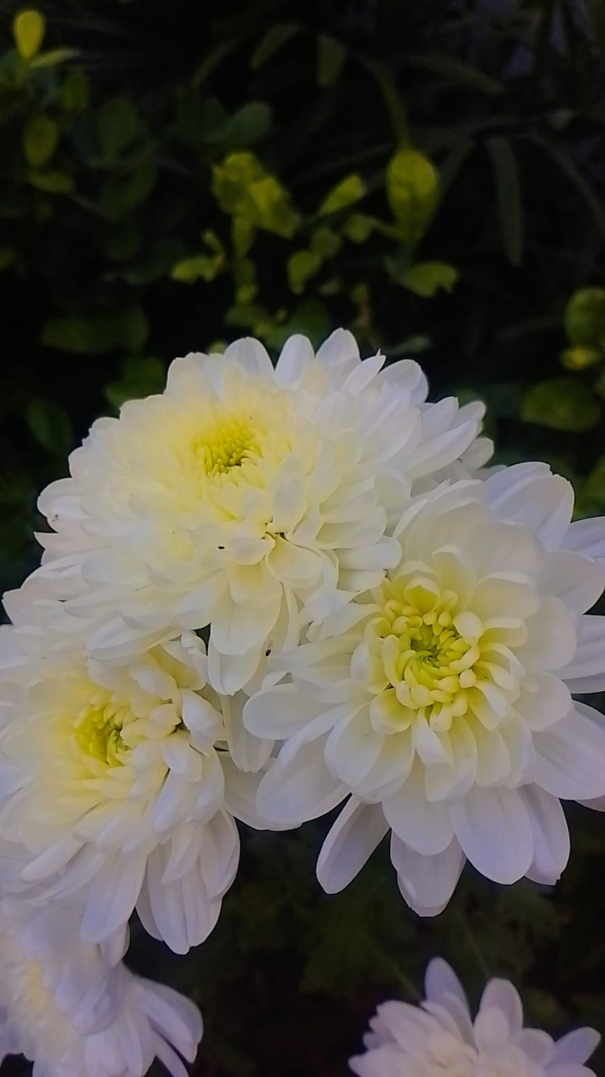

**إِنَّ فِي خَلۡقِ ٱلسَّمَٰوَٰتِ وَٱلۡأَرۡضِ وَٱخۡتِلَٰفِ ٱلَّيۡلِ وَٱلنَّهَارِ لَأٓيَٰتٖ لِّأُوْلِي ٱلۡأَلۡبَٰبِ**

**Translation:**

**Indeed, in the creation of the heavens and the earth and the alternation of the night and the day are signs for those of understanding.**

* Majestic Creation of Allah
* Seasonal changes in nature
* Some beautiful natural places in Pakistan
* Photobooth
* Discovery of Flower
* Nature’s Tear
* Importance of nature
* Poem: There will come soft Rains

TABLE OF

CONTENTS

**Majestic creation of Allah**

The beauty of **Allah's creation** can be seen in the many diverse forms of nature that exist around the world.

**In** every corner of the earth, there are aspects of nature that showcase beauty, peace, power, and mystery. Whether through the grandeur of **mountains**, the intricate design of flowers, the vastness of the sky, or the delicate creatures that inhabit our planet, the beauty of **God's creation** can be seen in countless ways. Nature not only **inspires** awe but also encourages reflection on the deep connection between the earth, its creatures.

**“Look deep into nature, and then you will understand everything better.”**  
 —**Albert Einstein**

* Mountains and Peaks
* Forests and Woodlands
* Oceans and Seas
* 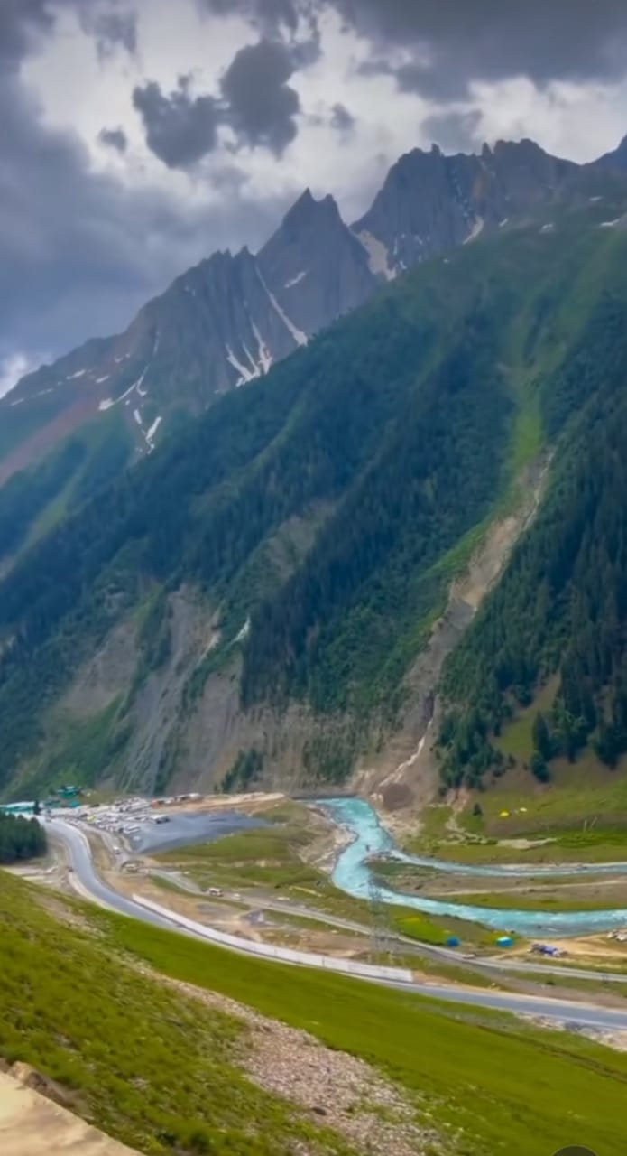Rivers and Lakes
* Deserts
* Wildlife
* Flowers and Plants
* Sunrises and Sunsets
* Clouds and Skies
* Caves
* The Changing Seasons
* Rain and Waterfalls
* Stars and the Night Sky

SEASONAL CHANGES IN NATURE

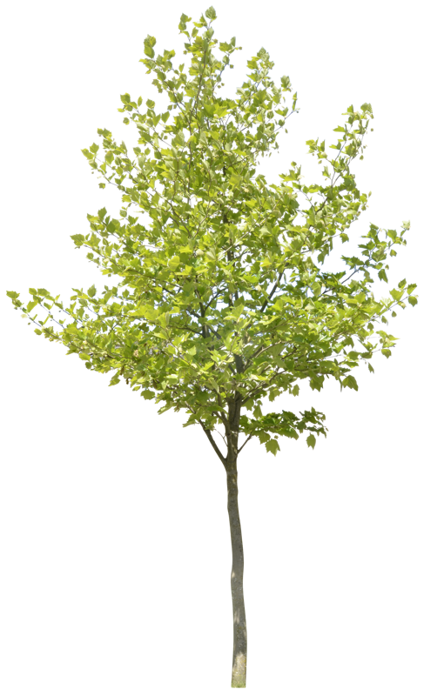

**SPRING**: Spring starts in March and ends in May. The weather starts to warm up, and the days get longer. Trees and flowers start to bloom, and animals come out of hibernation.

**SUMMER:** Mostly summer starts in June and ends in August. The days are long, and the weather is warm. Many fruits and vegetables are also in season during the summer.

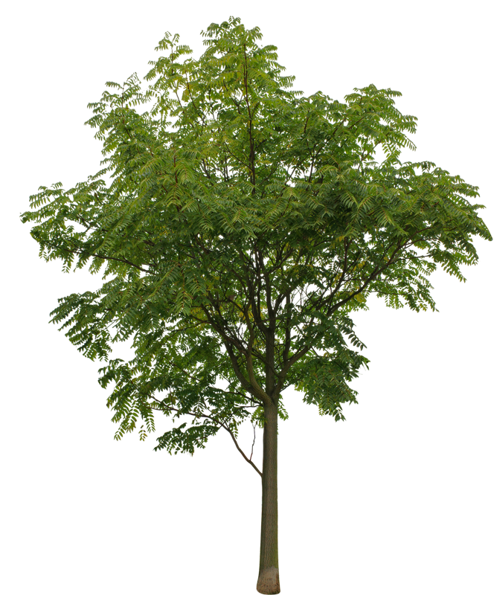



**FALL:** Fall starts in September and ends in November. The weather starts to cool down, and the leaves on trees change color and fall off.

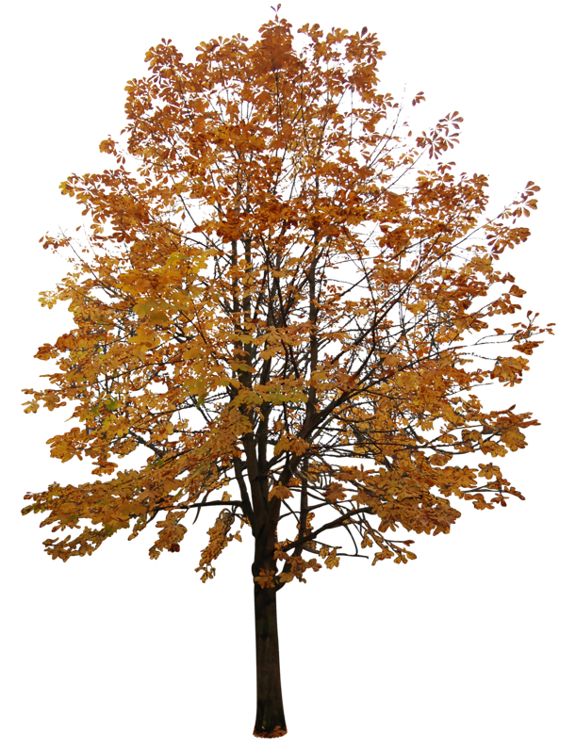

**WINTER:** Winter start in December and ends in February. The days are shorter, and the weather is cold. During the winter, many animals hibernate or migrate to warmer climates.

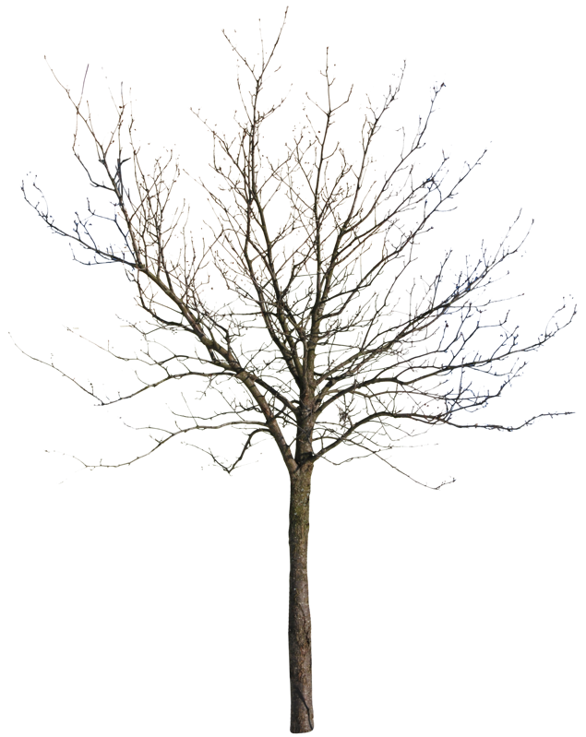

44

SOME

BEAUTIFUL

NATURAL

PLACES

IN

PAKISTAN

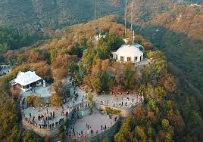

**Lake View Park**

Situated near the Rawal Lake in Islamabad, Lake View Park is a beautiful recreational park that offers a serene environment with plenty of green space.

The park is a perfect getaway for nature lovers, featuring picnic spots, walking trails, boating on Rawal Lake, and stunning views of the surrounding Margalla Hills. The lake itself is peaceful, with opportunities for birdwatching and enjoying the natural beauty of the area. Visitors can relax while enjoying the cool breeze, or go hiking.

* **Daman-e-Koh**

Daman-e-Koh is a famous viewpoint located in the Margalla Hills National Park, overlooking the city of Islamabad. The name "Daman-e-Koh" means "the foothills" in Urdu, and it offers panoramic views of Islamabad, including the city skyline, Rawalpindi, and the surrounding greenery.

It is a popular spot for both locals and tourists, particularly at sunset, when the view of the city below transforms with golden light. The area is accessible by car, and there are pathways for hiking in the surrounding hills, which are rich in flora and fauna.

**Margalla Hills National Park**

Margalla Hills National Park is located on the northern edge of Islamabad and is a prime spot for nature enthusiasts. The park is a mix of steep hills, lush forests, and diverse wildlife. There are numerous hiking trails, such as the famous trail to the top of the hill, where you can experience the fresh mountain air and stunning vistas. The park is home to several species of birds, monkeys, and other wildlife, and the flora is diverse, with various species of trees and plants. Hiking here is a popular activity, offering a peaceful retreat from the hustle and bustle of the city.

**Swat Valley**

Swat, often referred to as the "Switzerland of Pakistan," is a stunningly beautiful valley in Khyber Pakhtunkhwa, surrounded by the Hindu Kush mountains. It’s an absolute gem for nature lovers, boasting lush green valleys, rivers, and majestic mountain views.This is a well-known hill station in Swat, famous for its ski resort and breathtaking views. The area is perfect for adventure lovers and those who enjoy nature’s pristine beauty in winter and summer. Located near Mingora (the main city of Swat), this park is a peaceful spot to enjoy nature. It’s a popular place for tourists to relax by the river, surrounded by tall pine trees and cool, fresh air. his valley is one of Swat's most scenic spot. Some spectacular waterfalls, like **Ushu Waterfall**.

PHOTOBOOTH

***Physical Health:***

Nature Provides clean air, water, and food. Reduces stress and improves fitness.

***Mental Health:***

Reduces anger, fear, and stress. Increases pleasant feelings and well-being.

***Economic Benefits:***

Supports industries like agriculture, fishing, and tourism.

***Cultural and Spiritual Value:***

Source of inspiration, beauty, and spiritual fulfillment.

***Climate Regulation:***

Absorbs carbon dioxide, releases oxygen, and mitigates climate change impacts.

***Education:***

Offers opportunities for scientific research and learning. By protecting nature, we ensure a healthier and more sustainable future for all.

I

M

P

O

R

T

A

N

C

E

O

F

N

A

T

U

R

E

***Flower discovery***

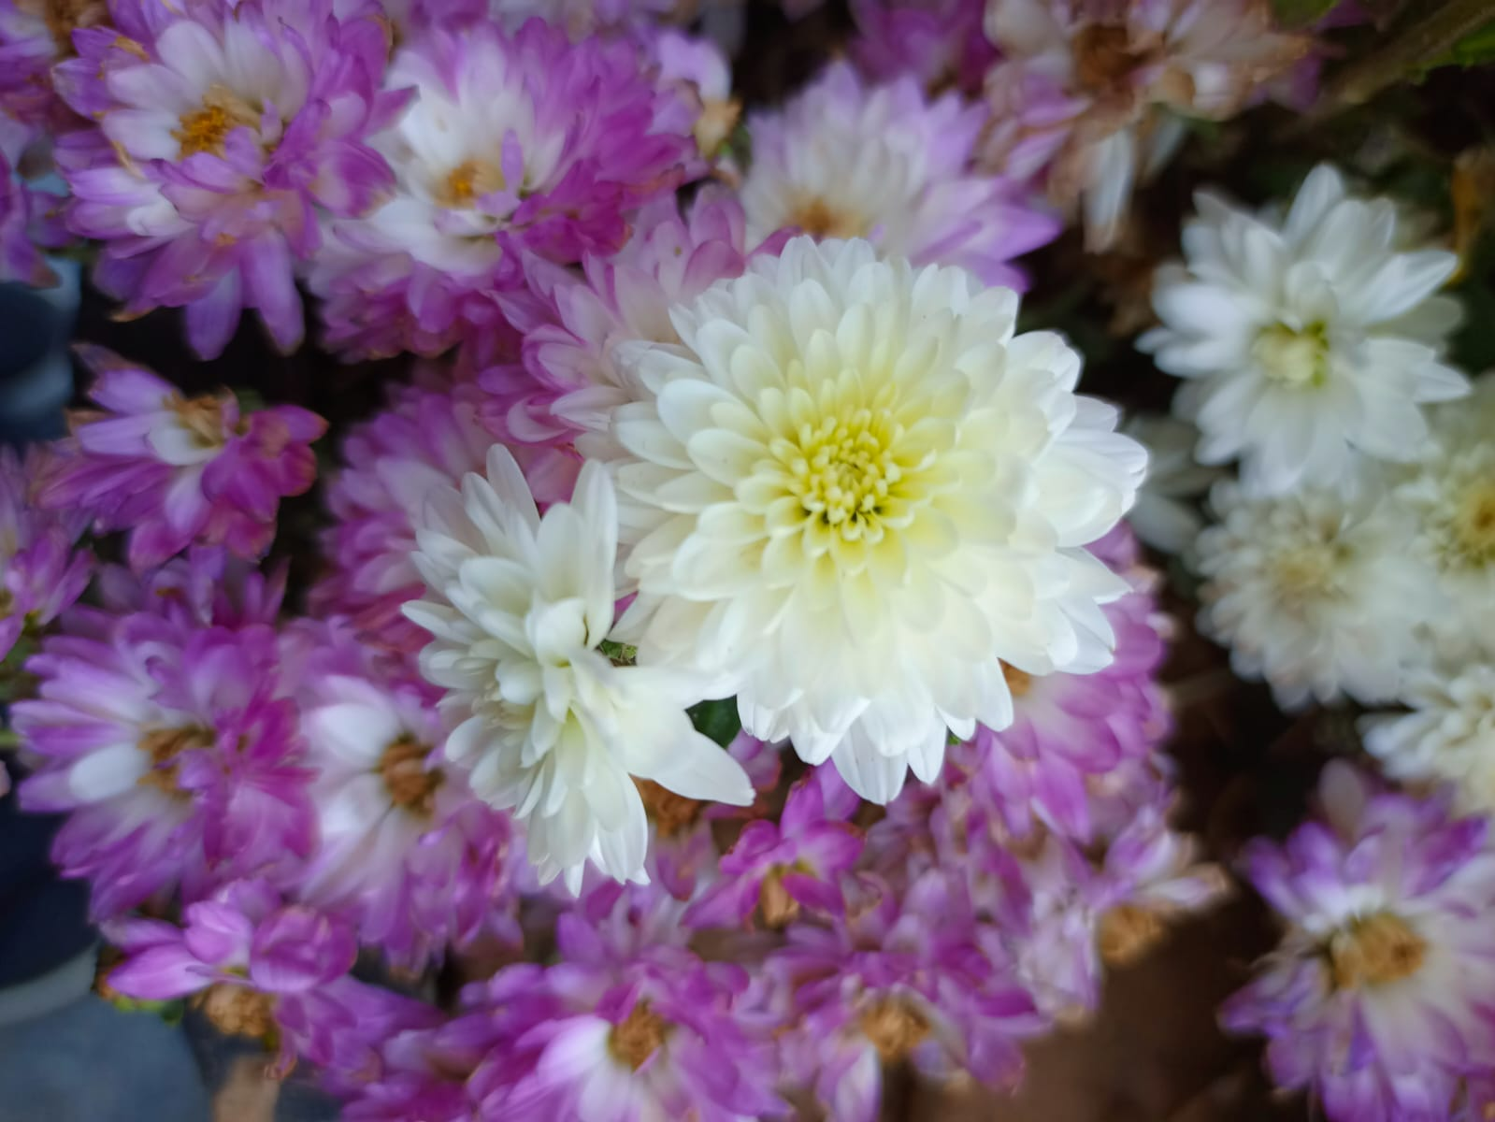

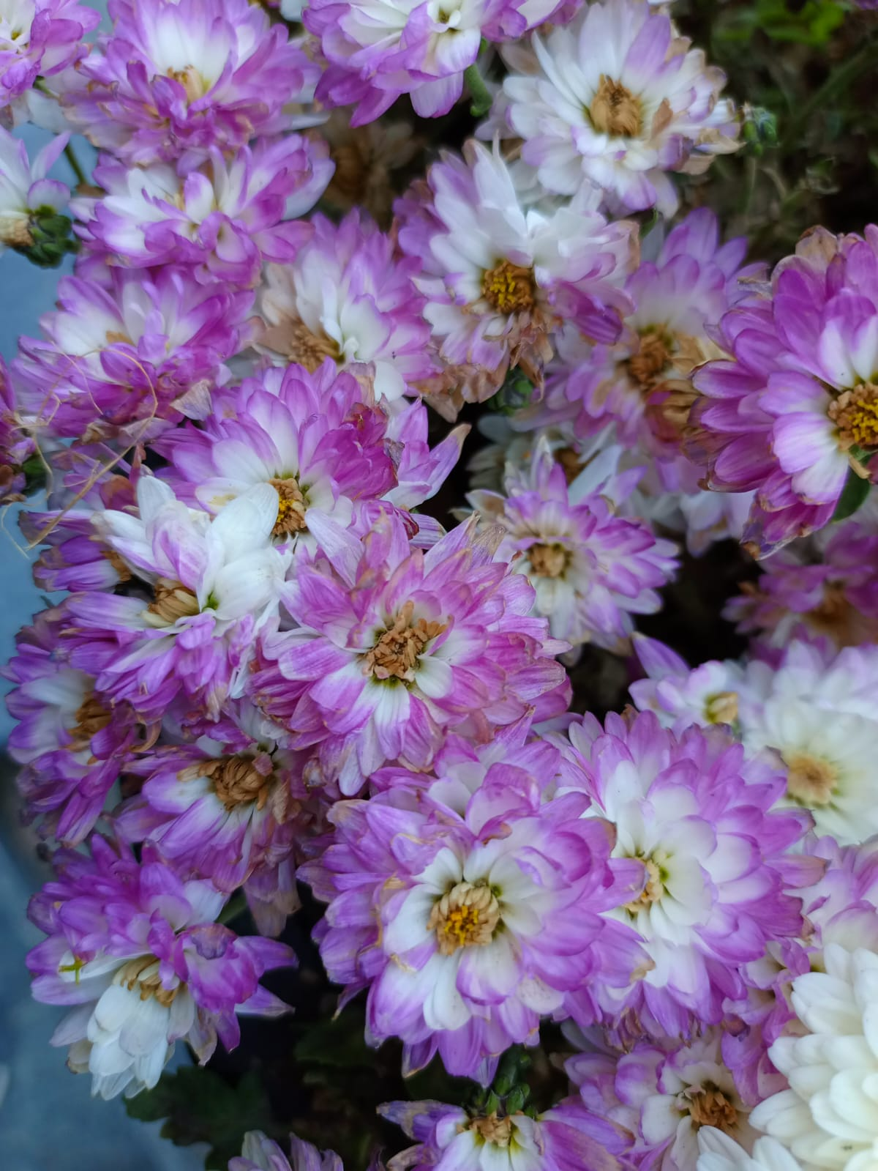

Nature’s Perfume

**The** scents of flowers are nature's perfume, a subtle yet powerful presence that can evoke memories and **emotions**. Each flower offers a unique **fragrance,** from the sweet aroma of roses to the exotic spice of orchids. These scents are more than mere pleasantries; they play a crucial role in attracting pollinators. The intricate dance of chemistry behind **floral fragrances** showcases nature's ingenuity, **blending** compounds to create olfactory masterpieces. Inhale deeply, and let the scent of **flowers transport** you to serene and enchanting places

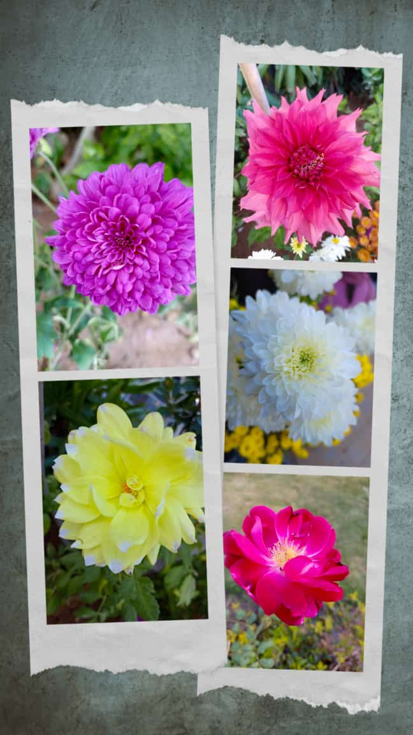

**Science**

**Behind Flower Colors**

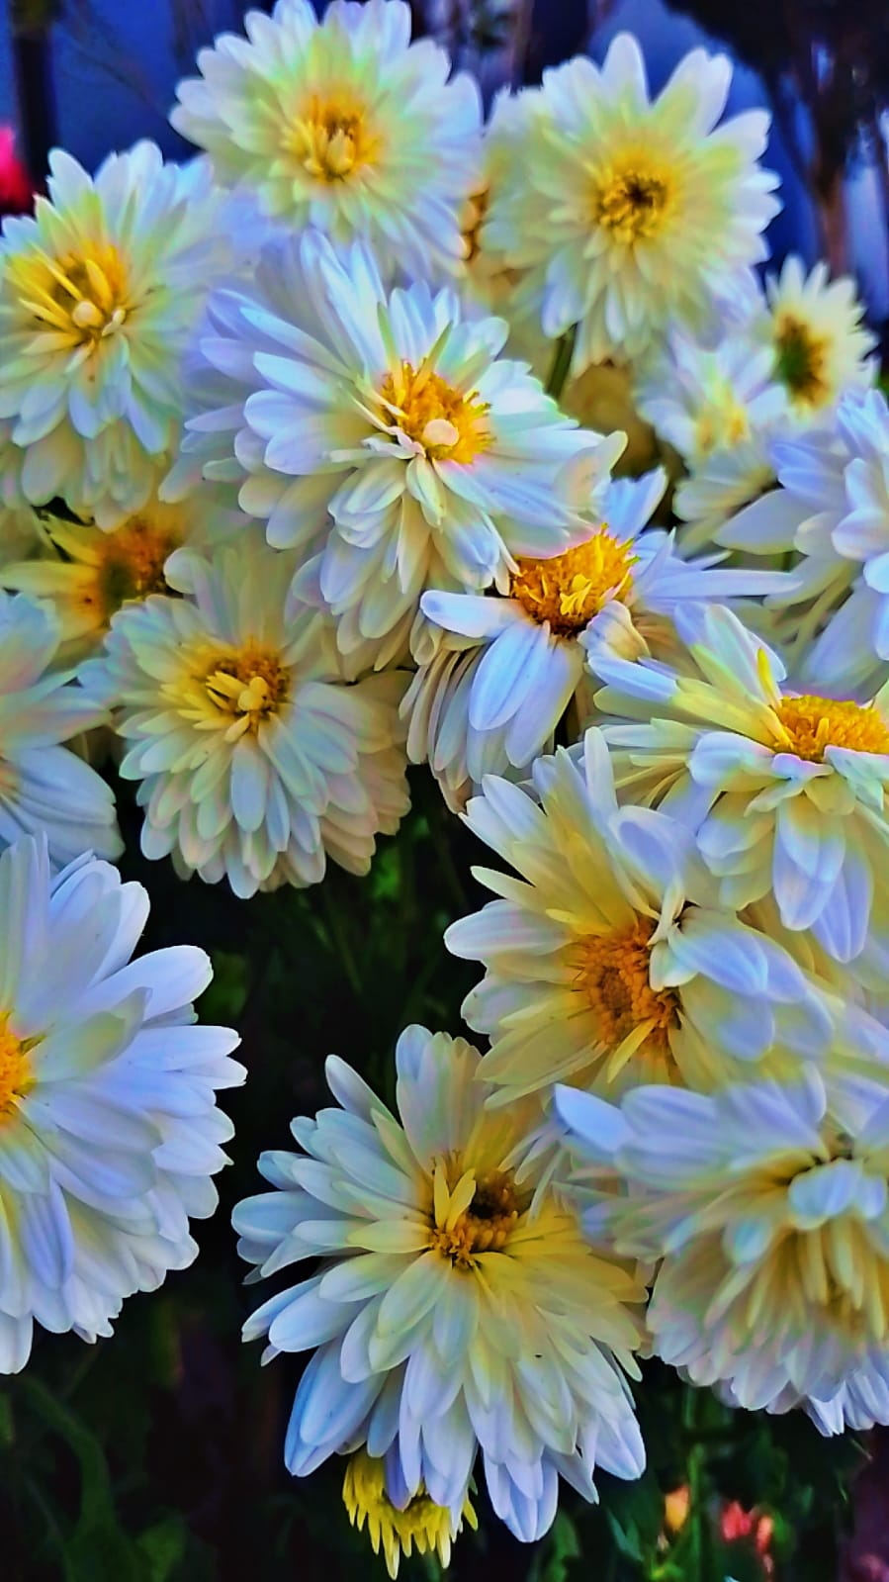The dazzling array of flower colors is more than just a visual feast; it is a result of complex biological processes. Pigments such as chlorophyll, carotenoids, and anthocyanins play a crucial role in determining the colors of flowers. These pigments not only attract pollinators but also protect the plant from harmful UV rays and herbivores. The interplay of genetics and environmental factors can influence the intensity and variety of colors within a single species. Understanding the science behind flower colors reveals the intricate mechanisms that nature employs to ensure the survival and propagation of plant species.

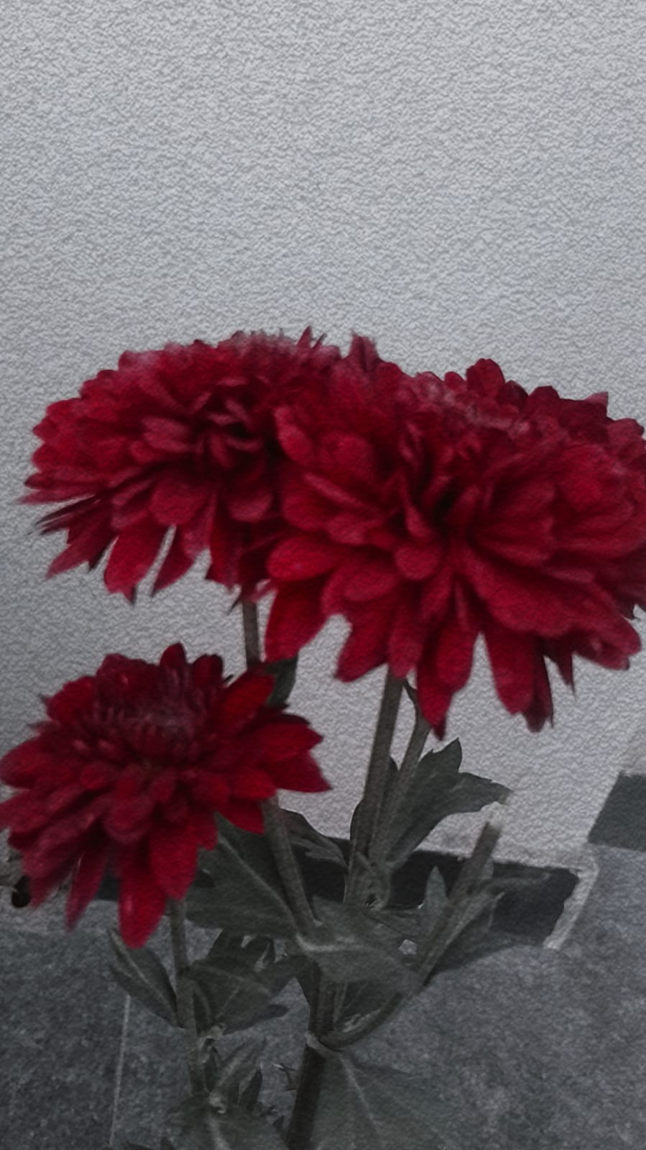

**Petals of Passion**

The vibrant and passionate hues of flowers have long been symbols of intense emotions and desires. The deep reds of roses and tulips often represent love and passion, while the fiery oranges of marigolds and poppies can signify enthusiasm and creativity. These passionate blooms are not only visually striking but also evoke strong emotional responses. Whether gifted in a bouquet or admired in a garden, petals of passion ignite our senses and remind us of the fiery emotions that color our lives.

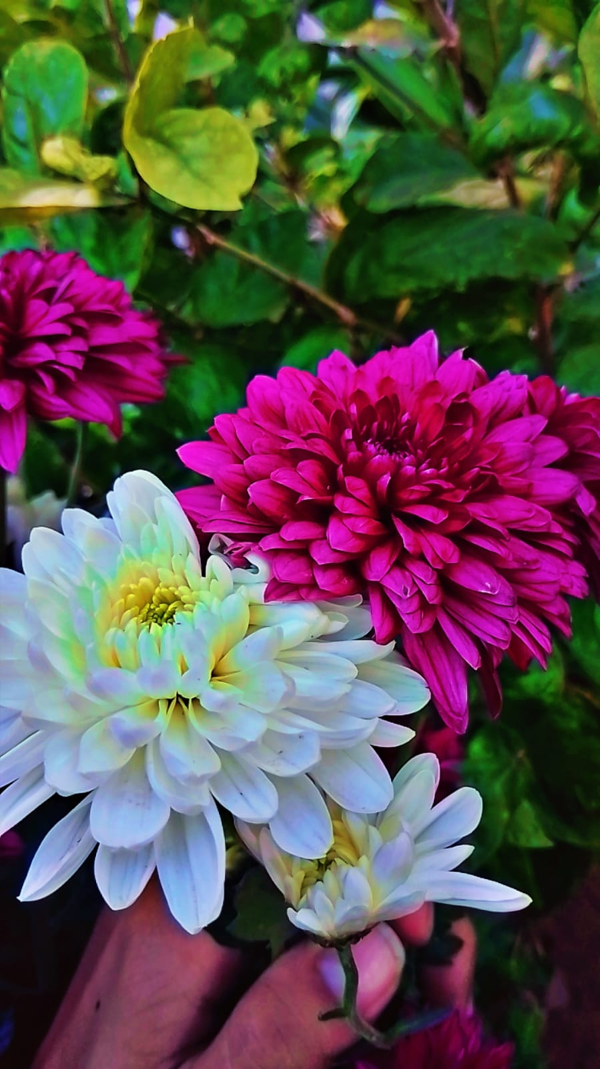**The Secret Lives of Flowers** Beneath their delicate exteriors, flowers lead secret lives filled with intricate processes and hidden wonders. From the way they adapt to their environments to their sophisticated methods of attracting pollinators, flowers are masters of survival and reproduction. Some flowers, like the night-blooming cereus, open their petals only under the cover of darkness.

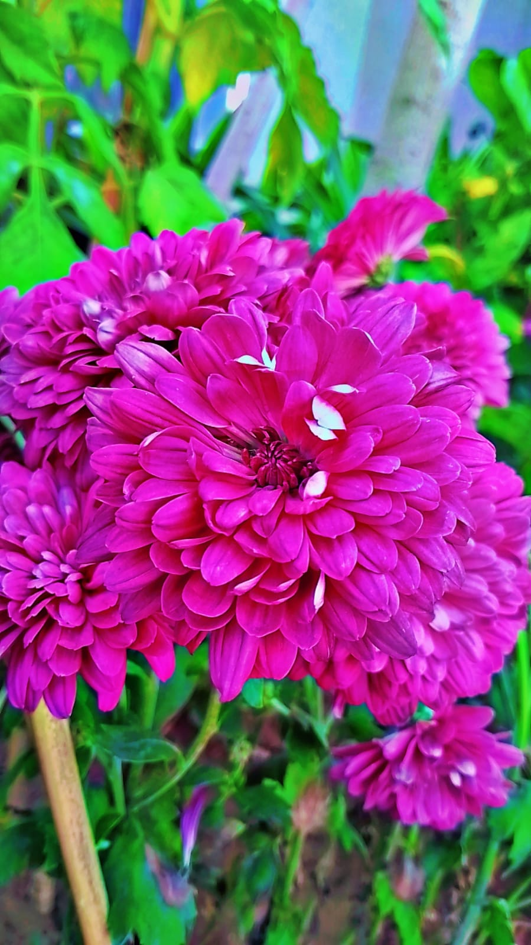

**Nature’s Tears**

R

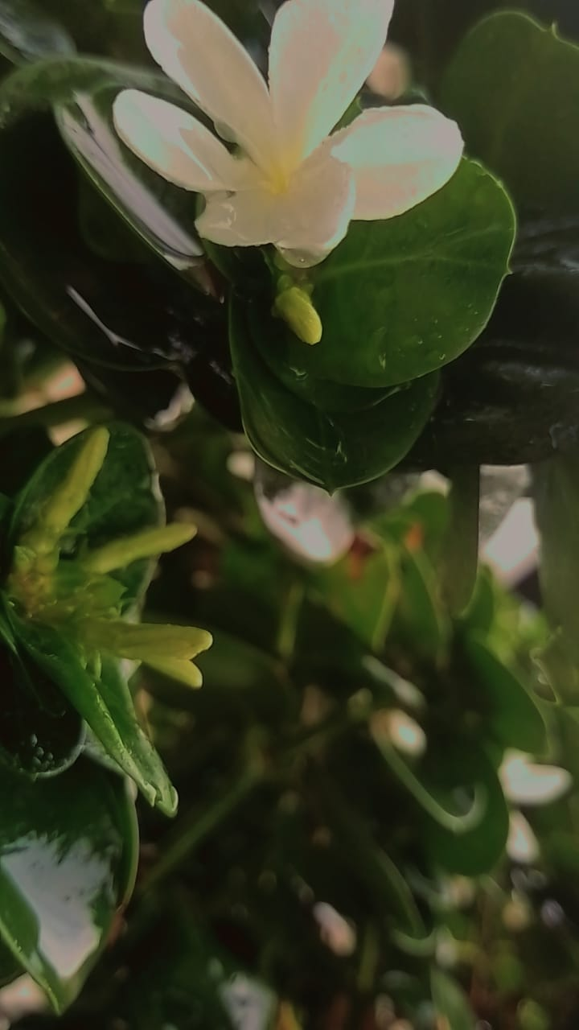

ain, often called nature's tears, is essential for life on Earth. It nurtures ecosystems, replenishes water sources, and supports plant growth. Each drop tells a story of renewal and sustenance, reminding us of the delicate balance in the natural world.

***There Will Come Soft Rains***

There will come soft rains and the smell of the ground,  
And swallows circling with their shimmering sound; in the pools singing at ght,  
And wild plum trees in tremulous white,

Robins will wear their feathery fire  
Whistling their whims on a low fence-wire;

And not one will know of the war, not one  
Will care at last when it is done.

Not one would mind, neither bird nor tree  
If mankind perished utterly;

And Spring herself, when she woke at dawn,  
Would scarcely know that we were gone.

-Sara Teasdale



